**Lab 5 : Logger**

**Ahmed Ashraf Ibrahim Khalil**

**$ sudo nano /etc/rsyslog.d/50-default.conf**

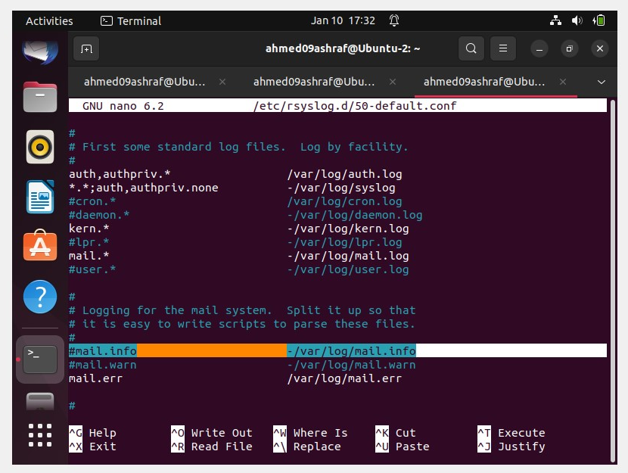

**$ sudo nano file.sh**

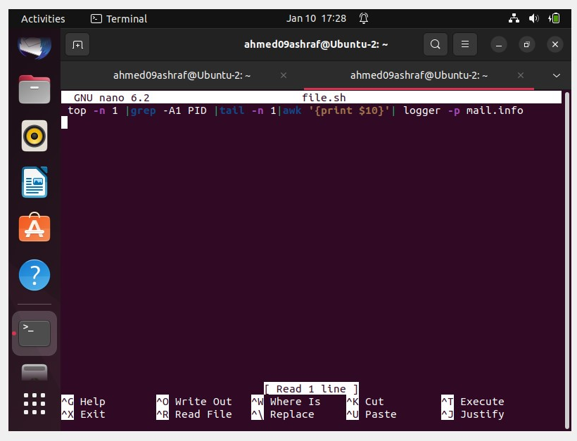

**$ crontab –e >>**

**But it run in Bg so it can’t show logger process changing in mail.log cat command ..**

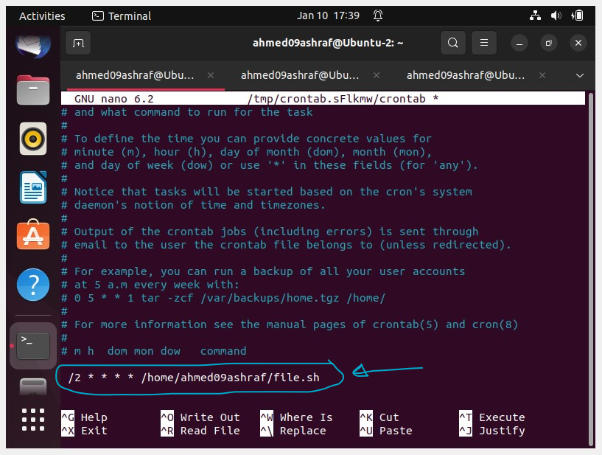

**Every execution of file.sh >>> give new value in mail.log**

